***Enterprise Chat System***

User Document V1.1

Date: 11-06-2017

**Team Name:**

**Wireshark**

**Team Members: -**

1. **Ginka Anusha**
2. **Gurram Karthik**
3. **Hossen Saddam**
4. **Injeti Ravi Varma**
5. **Ivvala Venkata Sai Krishna Chaitanya**
6. **Kadamati Venkata Sai Sidhartha**
7. **Karumanchi Mahesh Chowdary**
8. **Kondepati Divya Naga Krishna**
9. **Kovvuru Nasirali**

**10.Sathi Santhosh Reddy**

**11.Janagam Anirudh**

**Type of Document:** User manual instructions

**Version Number :**1.1

**Publication Date:** June 11th 2017

**1.General Information:**

**1.1 System Overview:**

Wireshark Messenger is an enterprise chat system which is a product developed for Xtreme security so that employees can communicate safely.  A central database is created to store user information metadata associated with each sent or received message, so that every user can see the date and time a message was sent as part of this conversation, the name of the sender and recipient, if the message was read by the recipient and when it was read and can browse the history of their conversations with various peers. Offline messages can be sent if the user is offline. Status of the user is updated as per their availability. User registration and user authentication (authentication is based on username or e-mail address and password).is set up such that they can access the chat system. Admin functionalities such as view user statistics, delete or block users is available. Communication between user to user and user to the server are encrypted. This product is a secured chat system and hides the confidential data against being encrypted from 3rd party security breaches.

**LOG MODIFICATIONS:**

**Release version 1.1 on 11/06/2017**

* **Added section 3.2 for user**
* **Added section 3.3 for admin**
* **User and admin roles have been clearly discussed.**

**Release version 1.0 on 28/05/2017**

* **Initial release**

# 2 Glossary and Abbreviations

**GUI:** Graphical User Interface.

**API:** Application programming interface

**SQL:** Standard Queuing Language.

**IP ADDRESS:** Internal Protocol Address.

**PHP:** Hypertext Pre-processor

**HTML:** Hyper Text Markup Language

**JSON:** JavaScript Object Notation

**REST:** Representational State Transfer

**API**: Application program interface

**MYSQL:** An open source relational database management system

**PHP:** Hypertext Pre-processor.

**3.Organisation of the model:**

The user’s manual consists of 4 sections: General Information, Glossary and abbreviations, System Summary, Getting Started.

* Section1: General Information section explains in general terms the system and the purpose for which it is intended.
* Section 2: Glossary and abbreviation: Technical terms used in this document
* Section 3: System Summary section provides a general overview of the system. The summary outlines the uses of the system’s hardware and software requirements,
* Section 4: Getting Started shows the installation process, chat system configuration for user and admin

**2.System summary**

System Summary section provides a general overview of the system. The summary outlines the uses of the system’s hardware and software requirements.

**2.1 System hardware requirements:**

* Windows / Ubuntu / MAC operating systems
* 32 / 64 - bit processor
* Internet Access
* Switch and cables (making a connection to the server)

**2.2 System software requirements:**

* Wifi access
* Internet Explorer/ Mozilla Firefox/Google Chrome
* XAMPP server
* Source code files

**3. Getting Started:**

**3.1 Installation of software and source codes:**

* XAMPP server should be installed as shown in the installation instructions.
* Source code files are copied to the **htdocs** folder of the XAMPP where it is installed.
* Database setup is needed to run the application
* Peers are connected to the same server using a switch.

**3.2 Configuration of the chat system for user:**

**3.2.1 User registration/login**

* Open the web browser.
* Copy the following URL code to the web browser

<http://localhost/wireshark/login.php>

* User Login/User registration web page is opened. In this page you will register is you are a new user and a user authentication mail is sent to the email.id which is used. If the user is already registered they can login into the chat system.

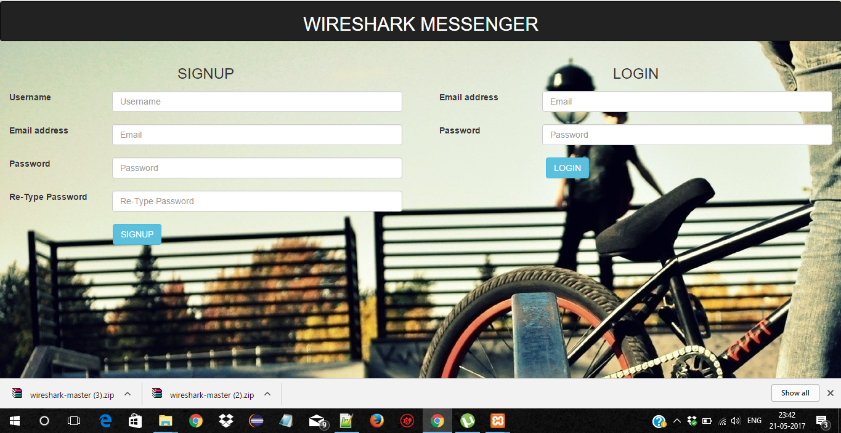

**3.2.2 User profile page**

* After a successful login, the user is redirected to the chat page where the user can select another user to start the chat.

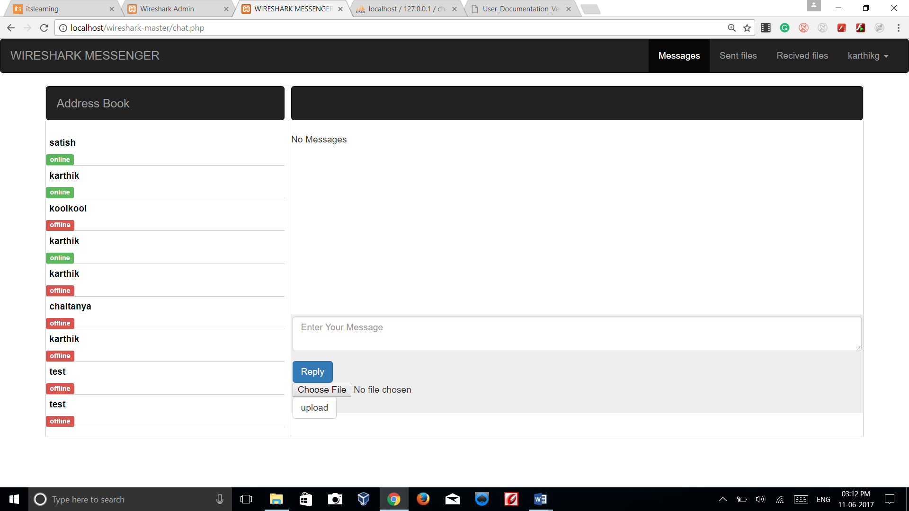

**3.2.3 Selecting a user from address book:**

* Online/offline users can be selected from address book to start a conversation

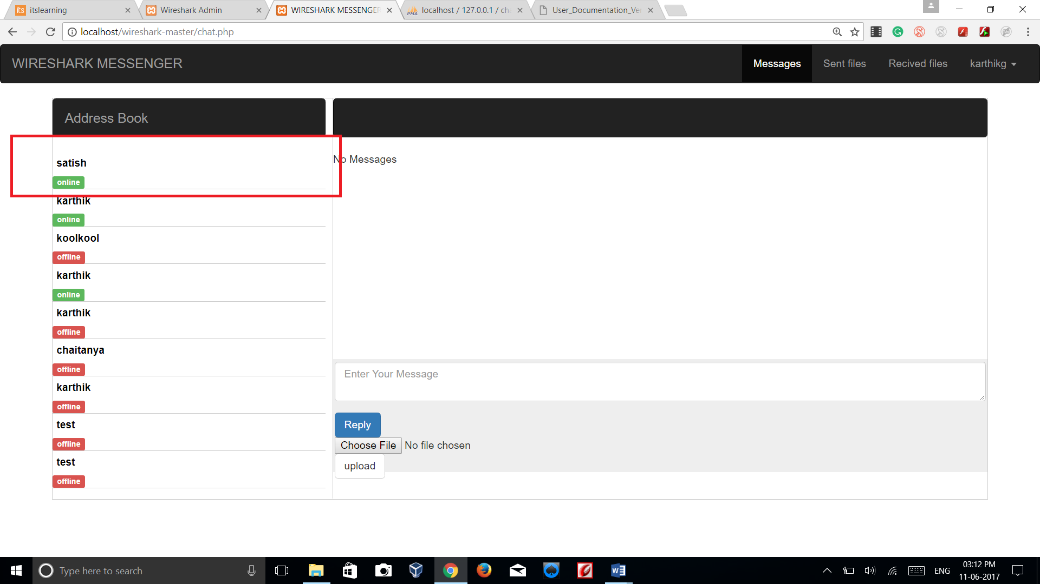

**3.2.4 Change status:**

* User can change his account/chat status from available to busy etc according to his preference

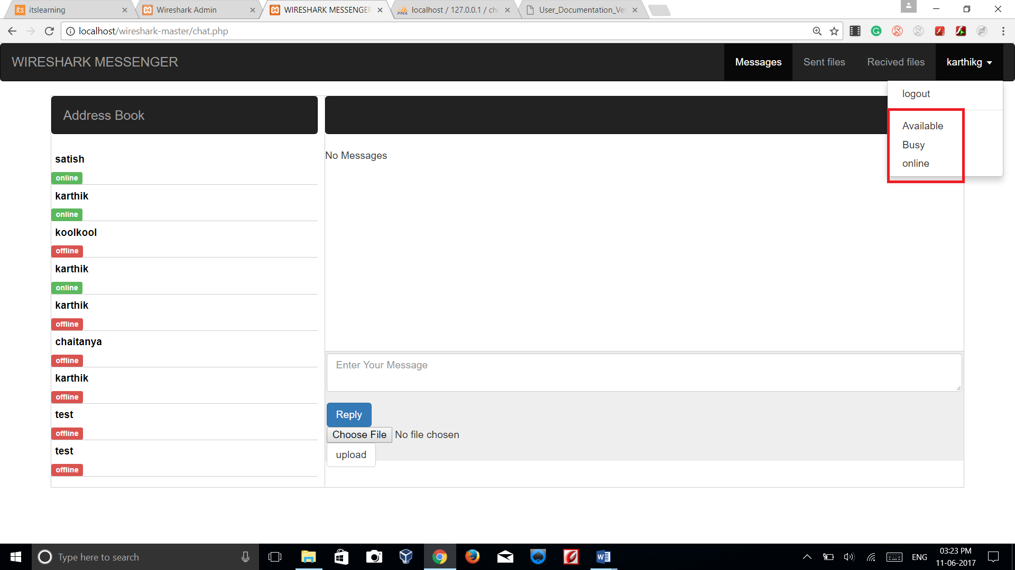

**3.2.5 Send and receive chat messages:**

* The user can select an another user from contact list/address book, start a conversation and can send and receive messages.

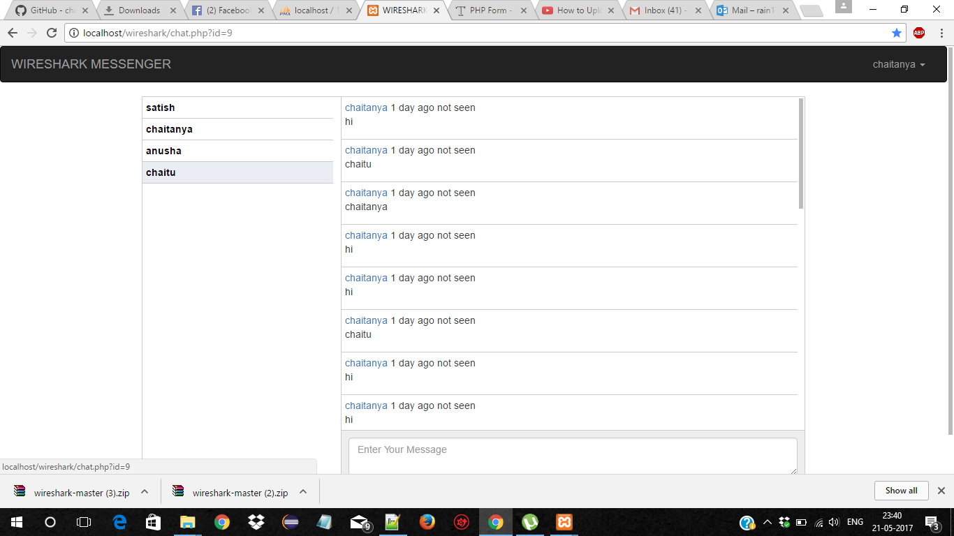

**3.2.6 Message unread/read status:**

* User can check if the message sent is read/unread

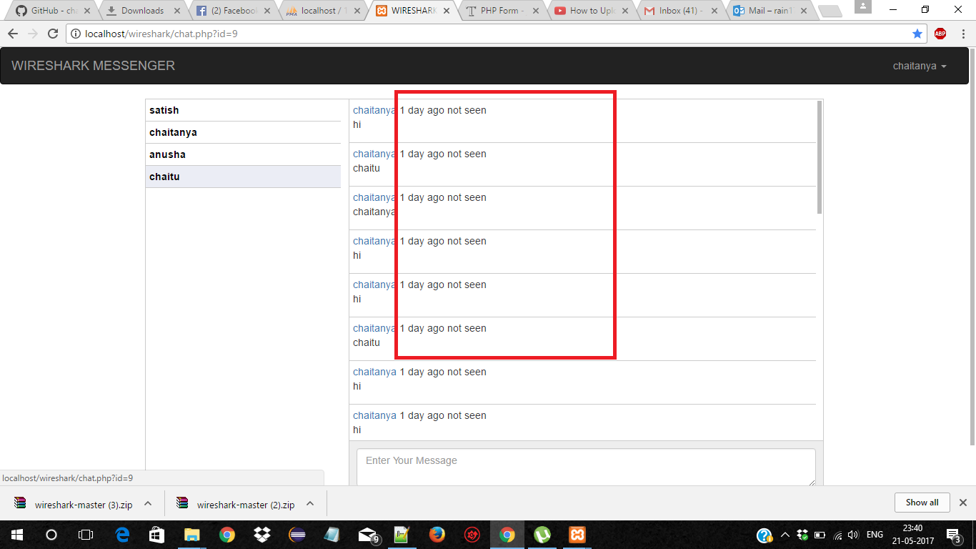

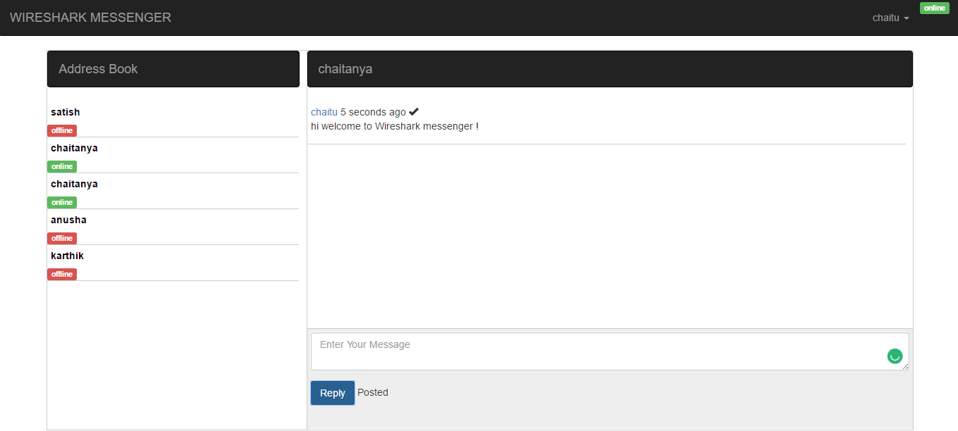

**3.2.7 Offline messages:**

* Whenever a user sends a message to another user, the message will be delivered through email if the user is in an offline state.

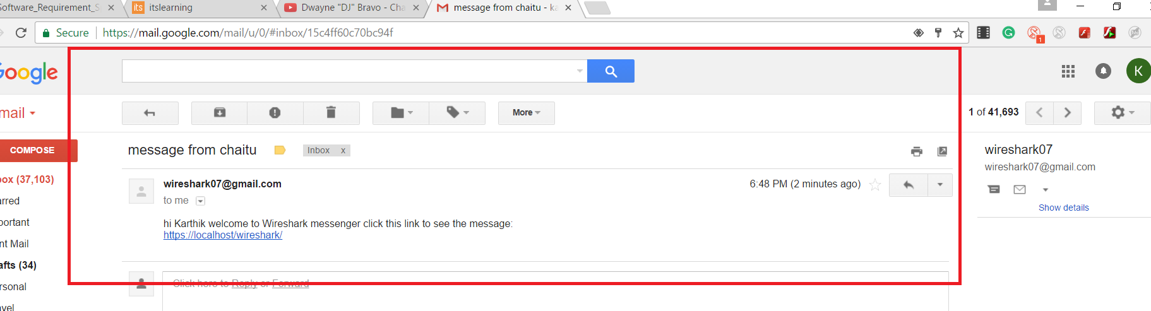

* The various other functionalities can also be viewed by the user in the user profile page.

**3.2.7 Logout:**

* When the user clicks on logout button on the profile page, the current session is destroyed and the user is redirected to the login page.

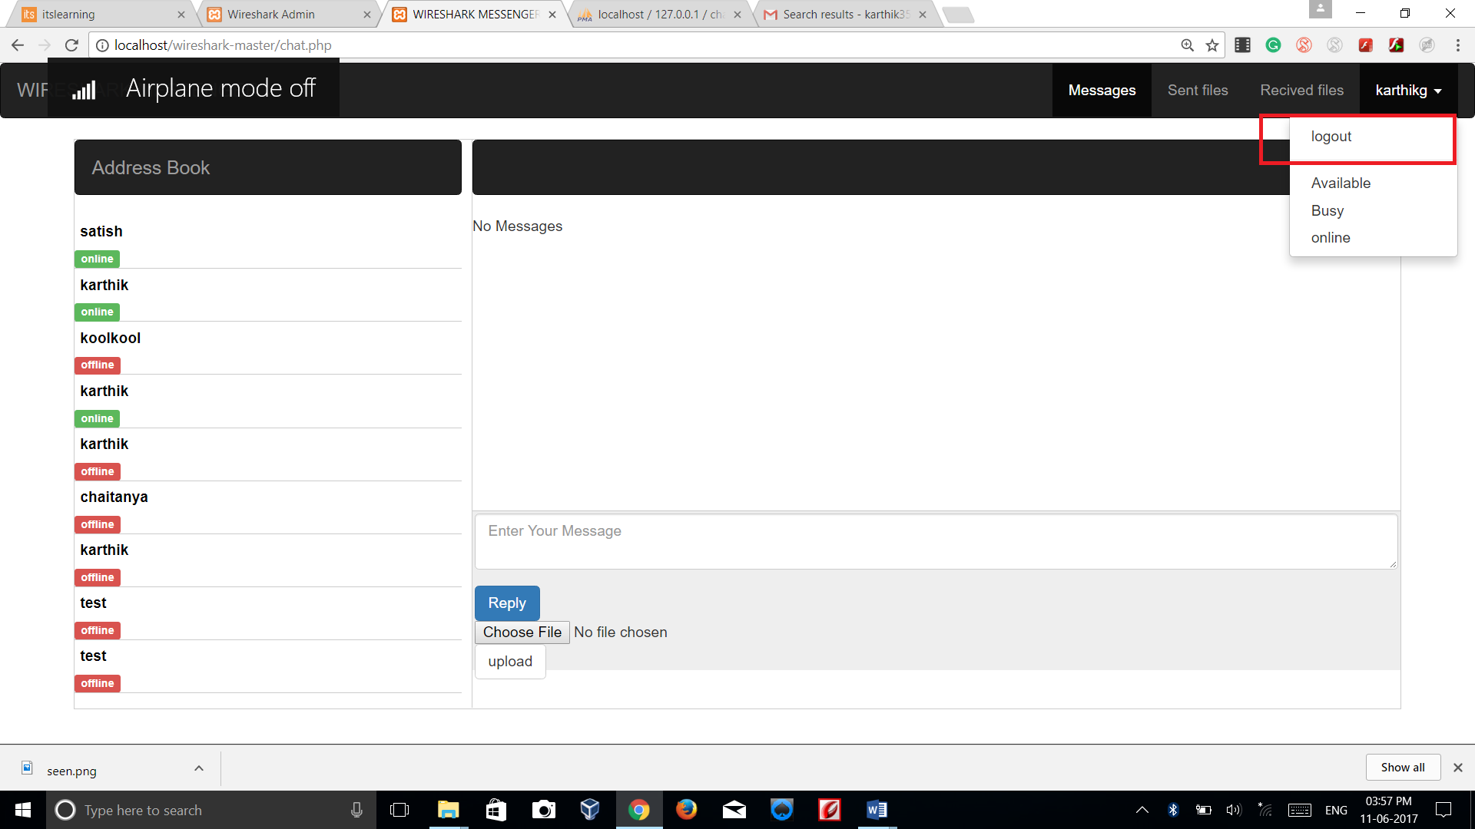

**3.3 ADMIN:**

**3.3.1 Admin registration/login:**

* Admin can login/register through the GUI by clicking on log in/signup buttons respectively.

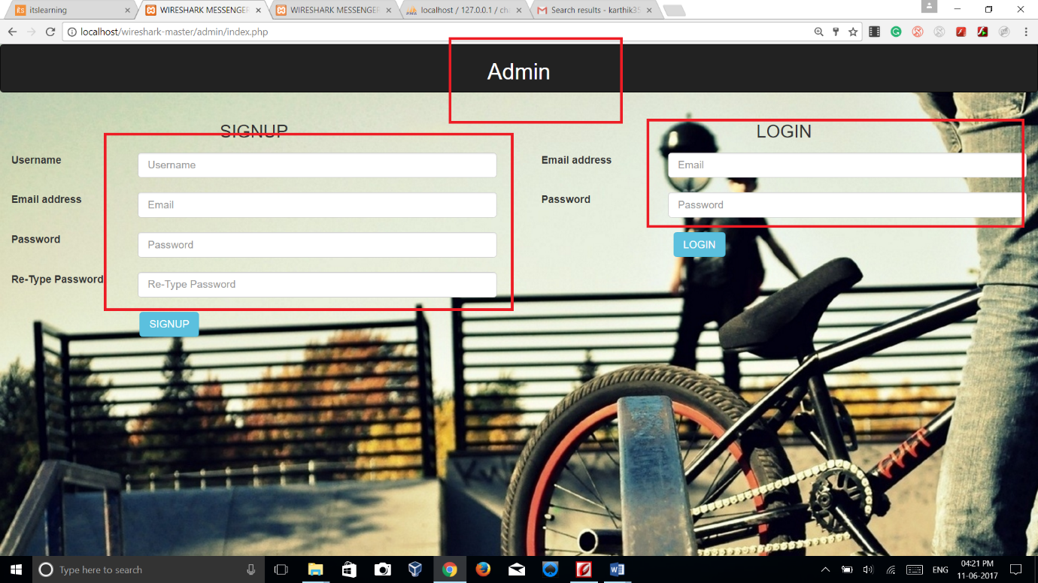

**3.3.2 View users**

* Admin can view all users available by clicking on view users button in the GUI

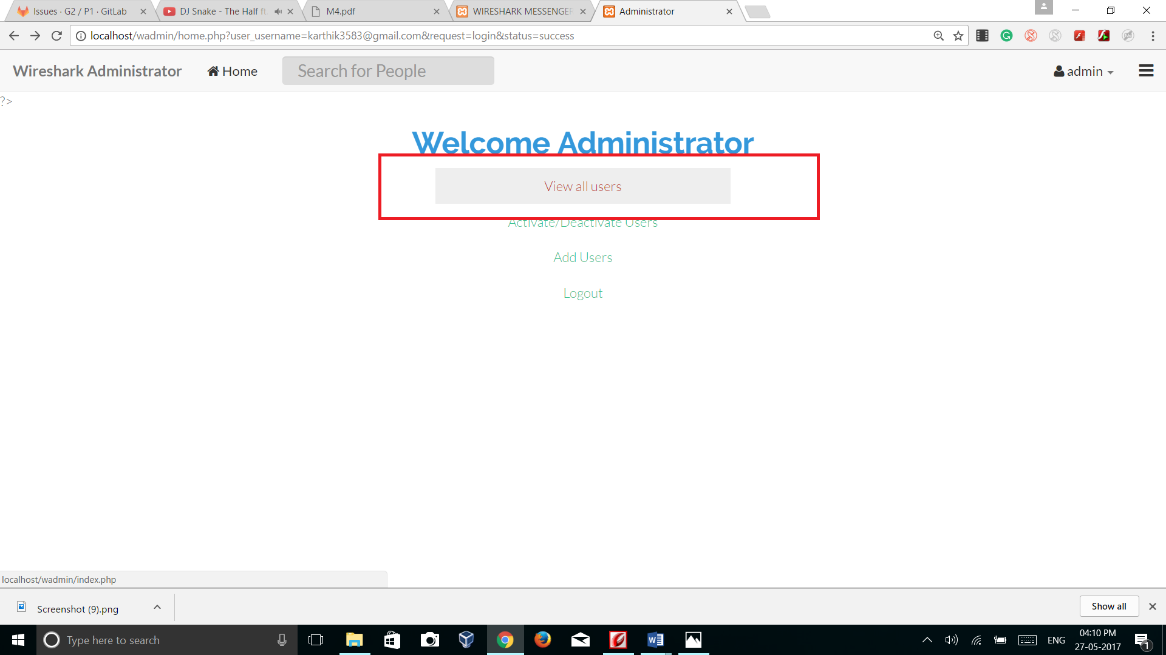

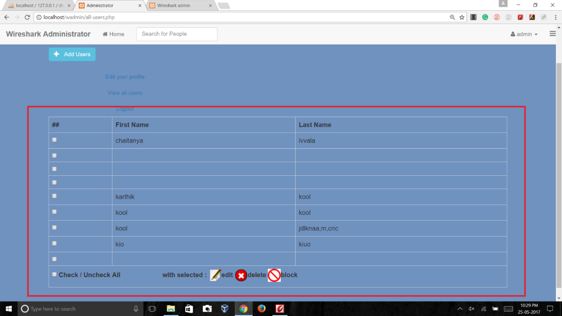

**3.3.3 Add New Users directly from admin panel:**

* Admin can add new users directly from admin panel by clicking on add user button.

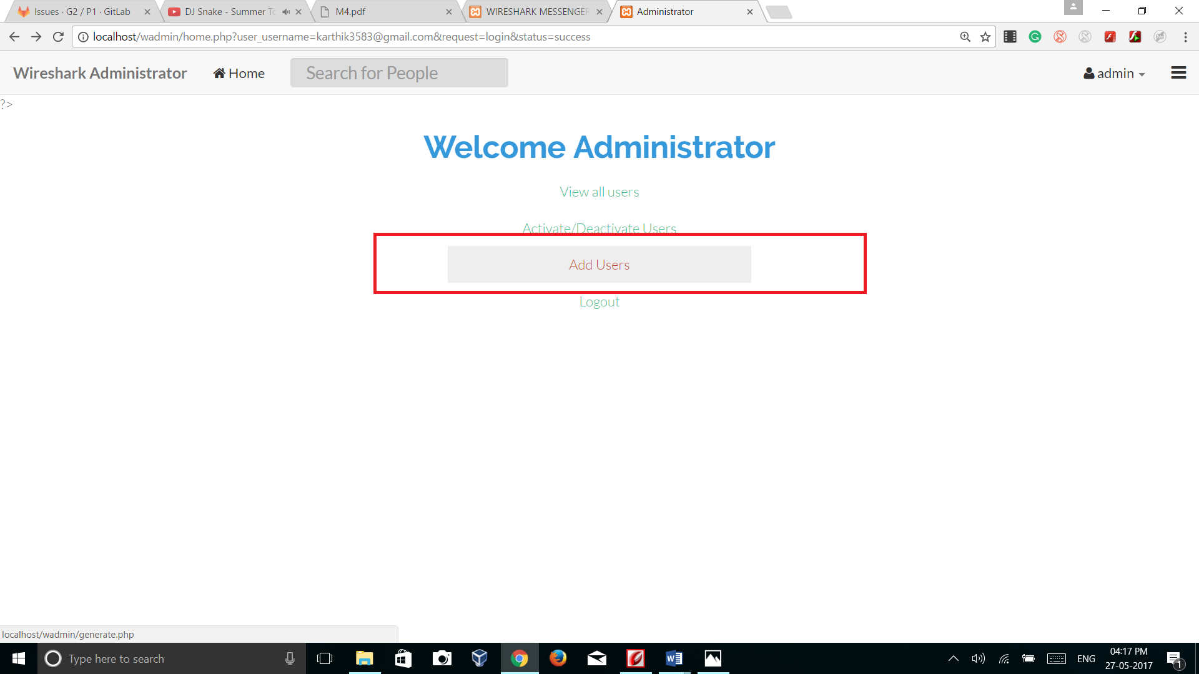

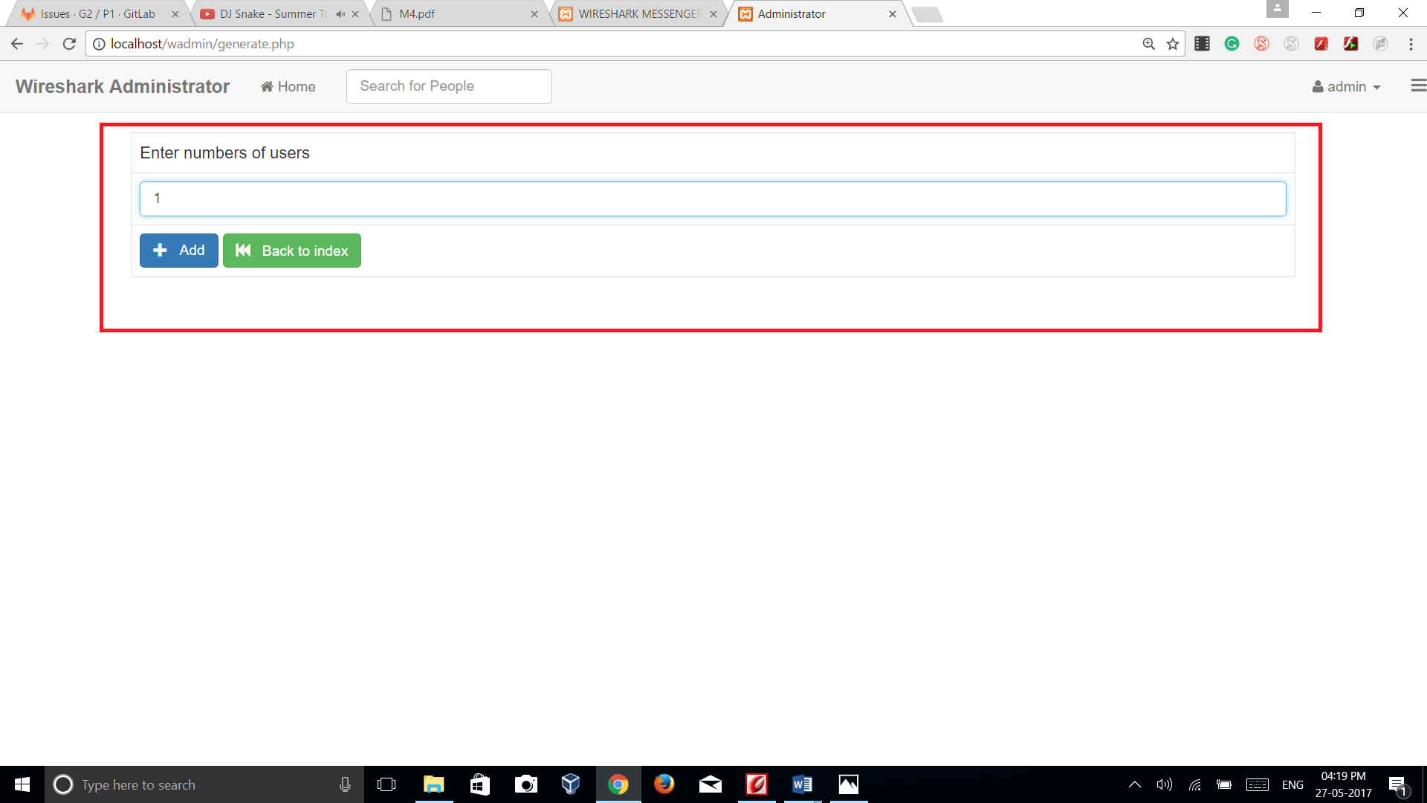

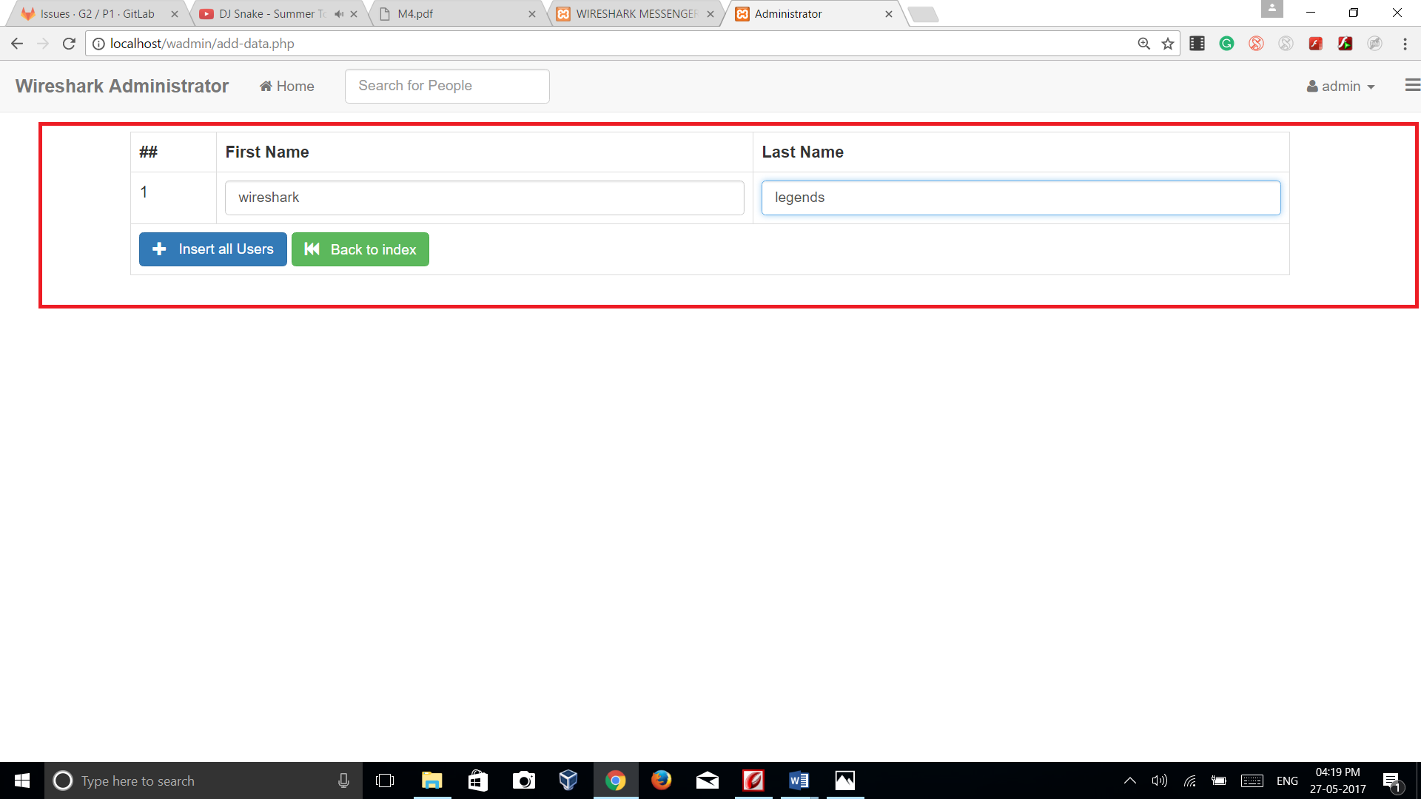

* 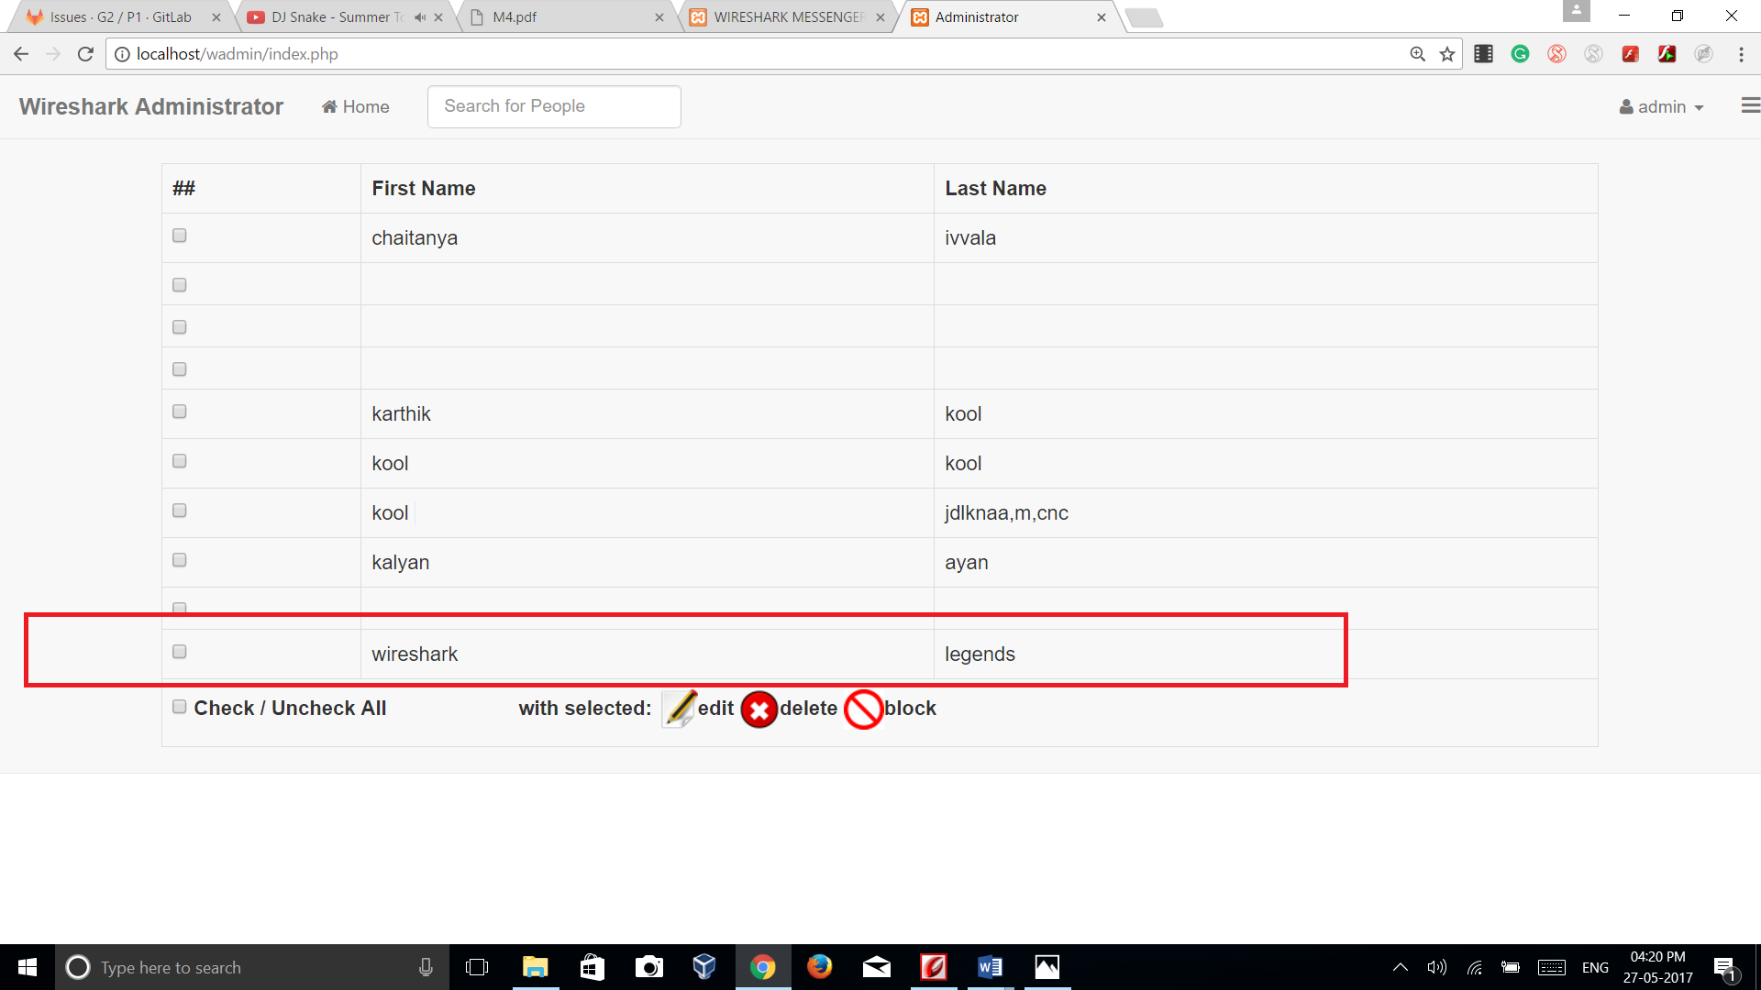

**3.3.4 Delete users:**

* Admin can delete users by clicking on delete button
* 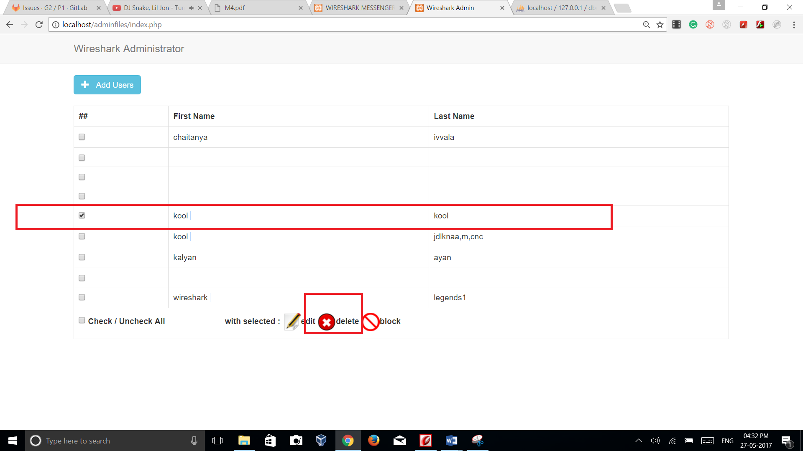
* 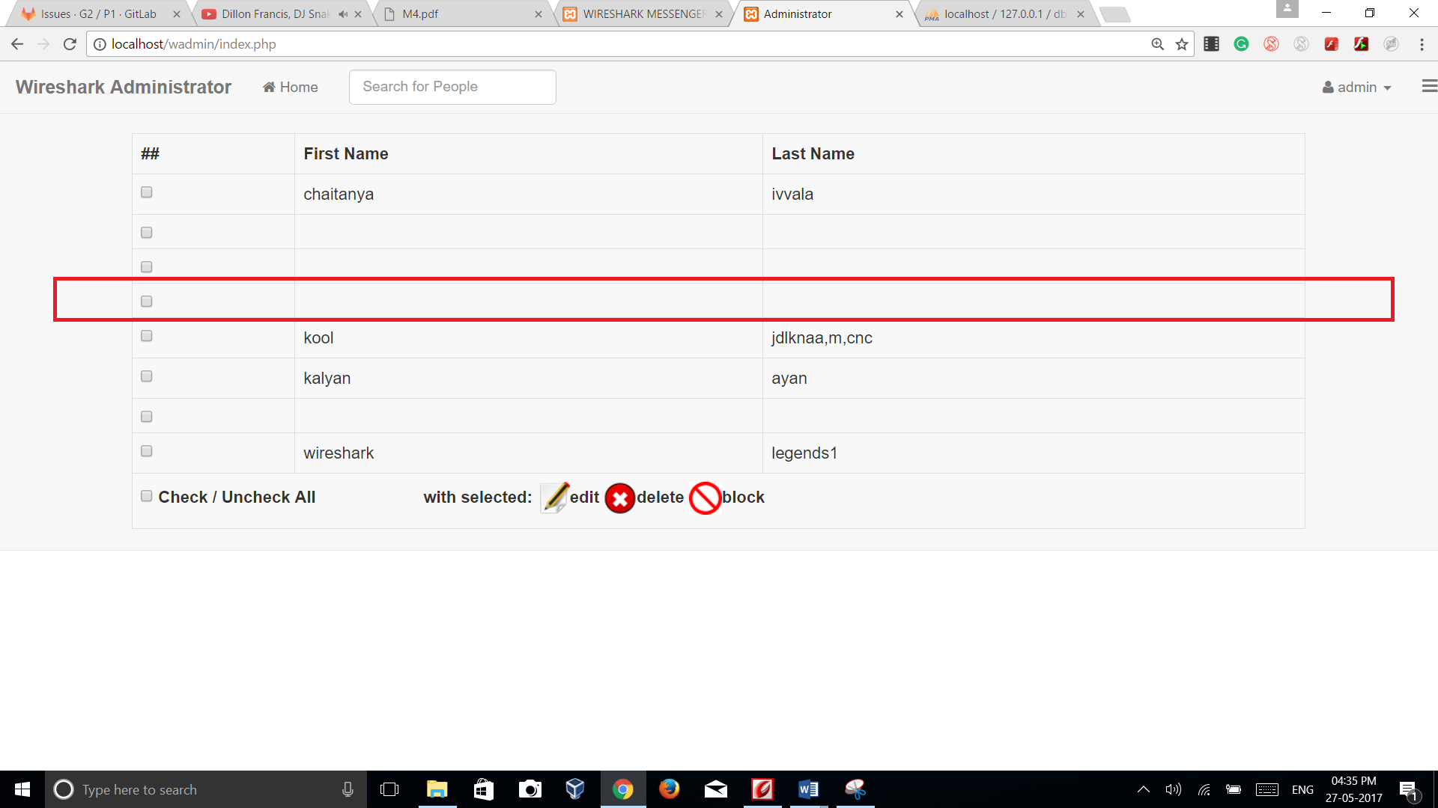

**3.3.5 Block/unblock users:**

* Admin can block/unblock users by clicking on block button available in the GUI

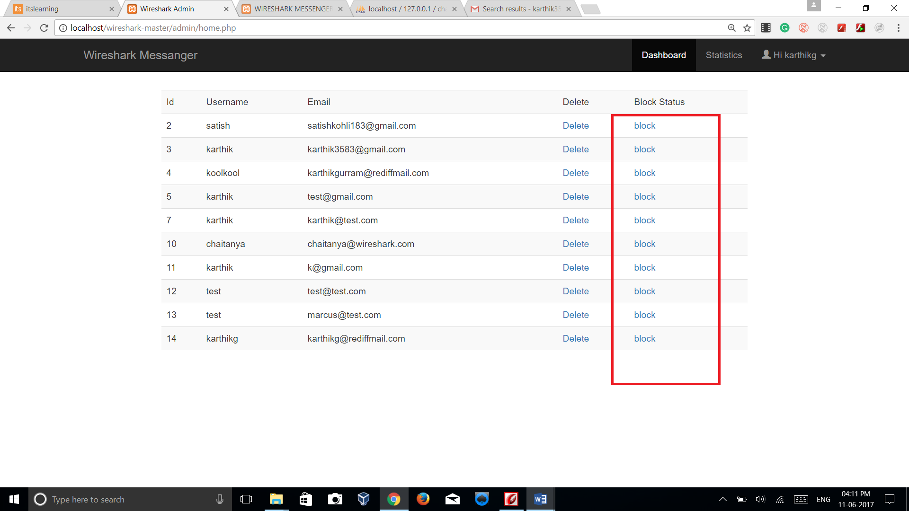

**3.3.6 View user statistics:**

* Admin can view statistics of the users by clicking on statistics button in the GUI.
* 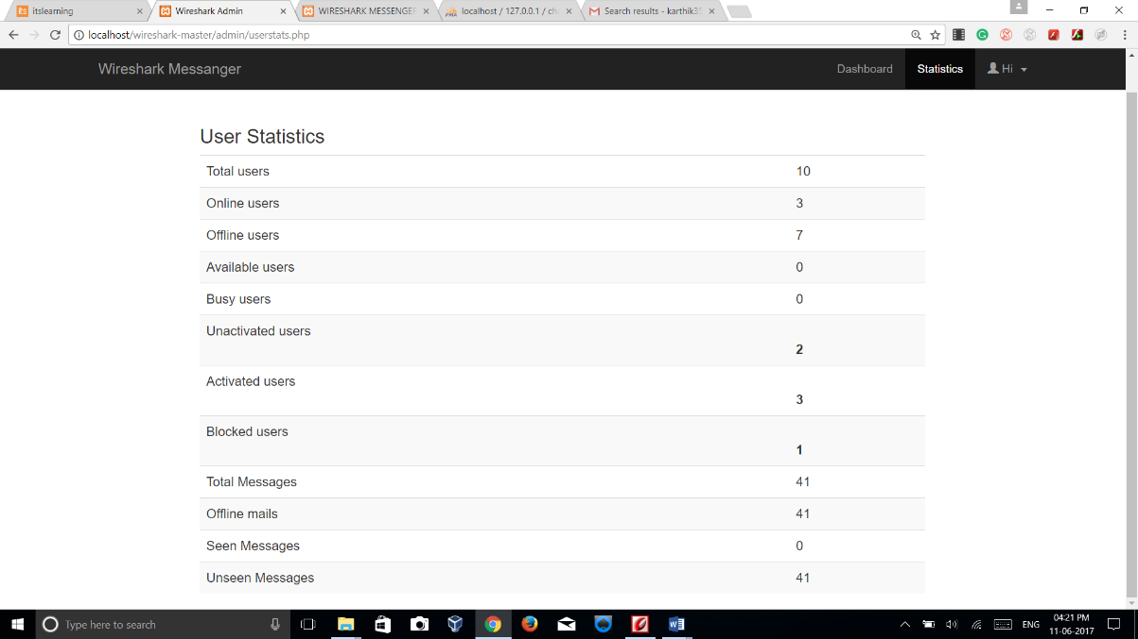

**3.3.7 Logout:**

* **Admin can log out of his account by clicking on signout button provided in the GUI.**
* 